SACE Stage 2 Physics
Uniform Circular Motion, Gravitation and Satellites Solution
Total mark: 21

Mean radius of Earth = 6.38 x 10⁶ m

Mass of the Earth = 5.98 x 10²⁴ kg

Universal gravitational constant G = 6.67 x 10⁻¹¹ N m² kg⁻²

1. The images shown below were recorded from placing a transparent sheet over a TV screen and marking successive images using a constant tmie rate between frames of an object rotating with a constant speed, clockwise in a circle.

(a) Use a vector analysis to show that the change in velocity of the object over two successive intervals is directed approximately towards the centre of the circle.
(2 marks)
(b) Given 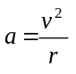for the magnitude of the centripetal acceleration a, where v is the constant speed of the object and r the radius of the circle, derive the relationship 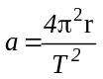 where T is the period of revolution.
(3 marks)

2. A car, mass 450 kg travels in a circle of radius 250 m with a speed of 55 km h⁻¹.
(a) Determine the magnitude of the centripetal acceleration of the car.
(2 marks)
(b) If travelling at a speed just greater than this the car slides off the road surface, calculate the magnitude of the frictional force between the road surface and the car.
(1 mark)
(c) If the road surface had been “banked” at an angle of approximately 6º, the car would have been able to travel around the bend at a speed greater than 55 km h⁻¹.

(i) Explain why banking of a road enables the car to travel around a bend at a speed greater than that when travelling on a horizontal road surface with the same car and radius of curvature.
(2 marks)
(ii) Determine the speed at which the car could travel around the banked curve if friction is not to provide any of the force required for centripetal acceleration.
(2 marks)
3. (a) Show that the speed of a satellite in a circular orbit about the Earth is independent of the mass of the satellite.
(2 marks)
(b) A satellite orbits the Earth with a period of 8 hours. Determine the height the satellite orbits above the Earth’s surface.
(3 marks)
4. (a) Explain why the orbit shown below would not be possible for a satellite in orbit about the Earth. The satellite does not have a propulsion system.
Earth

(2 marks)
(b) What is the advantage of launching a satellite
(i) from the equator
(ii) in an west to east direction?
(2 marks)

SOLUTIONS

1.
(a) (uses average velocity, could approximate
tangential instantaneous velocity vectors)
v₁
v₂
-v₁
Δv

(b)
Since definition of speed is 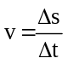 then in one revolution 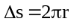in period T.
Hence substituting 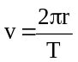 into 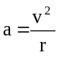 gives 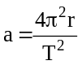

2. R = 250 m, m = 450 kg. v = 55 km h⁻¹
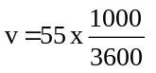 = 15.28 m s⁻¹
(a) = 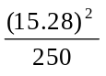= 0.93 m s⁻²
(b) since the frictional force supplies the centripetal force for the car to turn in the circle,
F _{friction} = F _{centripetal} = 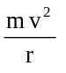
= 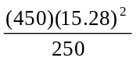 = 420 N
(c) (i) When a bend is banked, then the horizontal component of the normal force the road exerts on the car provides the centripetal force.
Thus the motion of the car around the bend becomes independent of the frictional force (provided the speed does not exceed a critical value)
Normal Force
Horizontal component of Normal Force
Vertical component of the Normal Force
Gravity Force

(ii) 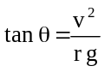
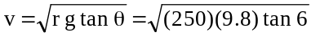
= 16.05 m s⁻¹ (= 57.8 km h⁻¹)

3. (a) The gravitational force of attraction between the Earth and the satellite provides the centripetal force, then
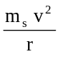 = 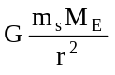
Re-arranging
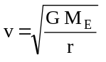 and as these values are constant, then the speed is
independent of the mass of the satellite.
(b) and as 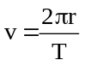
re-arranging gives 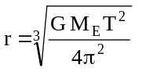
=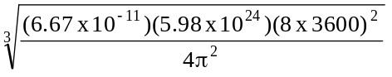= 2.03 x 10⁷ m
Height = 2.03 x 10⁷ - 6.38 x 10⁶
1.39 x 10⁷ m

4. (a) In this case the gravitational force cannot provide the centripetal force to keep the satellite in orbit as they are in different directions. (This means that an additional force, hence propulsion system would be needed for the orbit shown.)
Earth
F _{centripetal}
F _{gravitational}

(b) the advantages are:
(i) The Earth rotates from East to West. Hence the Earth’s speed contributes to the final orbital speed of the satellite, reducing the cost of launching the satellite.
(ii) For geostationary orbits, it is most economical to have the launch site on or near the equator, as the satellite will then be in the equatorial plane. Again reducing the cost of moving the satellite to an equatorial orbit.

